Title: Liaison response to ITU-T SG15 LS-165
From: IEEE 802.1
For: Action
Contacts: Glenn Parsons, Chair, IEEE 802.1 (glenn.parsons@ericsson.com)
To: ITU-T Study Group 15 (tsbsg15@itu.int)
Tom Huber (Rapporteur Q9/15), Tom.Huber@coriant.com
Han Li (Associate Rapporteur Q9/15), lihan@chinamobile.com

Mr. Huber, Mr. Li,

Thank you for your liaison COM 15 – LS 165. We appreciate your facilitating review by ITU-T Q9/15 of IEEE P802.1AX-REV draft 4.3 and making one of the goals of your MDSP work in progress to be compatible with DRNI.
Regarding your request for a summary of how changes since draft 3.0 would have affected our response to your past liaison COM 15 – LS076, we do not believe that any of the changes would have affected the response.
Regarding your item 1 in regards to Figure 1, if a failure occurs in the left hand side “Protected Domain” that prevents traffic from being delivered (as it normally would) to the upper node on the left hand side of the ENNI, DRNI can adapt to this failure using the updateDRFHomeState function. Upon detecting that connectivity through the Gateway corresponding to the upper node on the left hand side of the ENNI is no longer enabled by the operation of the network control protocol, this function sets internal information reflecting that this Gateway is no longer operational and that the Gateway corresponding to the lower node on the left hand side is instead newly operational.
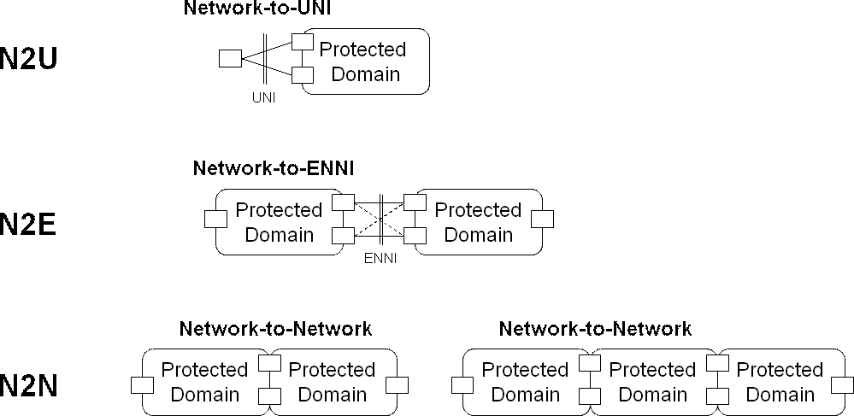
Figure 1
Regarding your item 2, IEEE P802.1AX-REV does support a non-default mode of operation thereby traffic is relayed via the Portal System hosting the Aggregation Link(s) carrying this traffic across the DRNI (so as to minimize IPL traffic). The failure-free ENNI of Figure 1 is used as an example. In this example and focusing on the left hand side of the ENNI, the upper link and the Gateway corresponding to the upper node are selected for a given conversation that maps to a VLAN reachable via the lower node. If the conversation moves to the lower link, it has to traverse the IPL, enter the network via the Gateway corresponding to the upper node and be relayed through the network back to the lower node to reach the VLAN it maps to. The non-default mode of operation can be enabled so the conversation does not have to traverse the IPL and can instead enter the network directly through the Gateway corresponding to the lower node. To summarize, this non-default mode of operation effectively allows the Gateway to change based on DRNI operation while the default mode of operation leaves the choice of the Gateway used for a given conversation to the network. A Boolean switch (aDrniPortConversationControl) determines the chosen mode of operation. When the non-default mode is selected, the Home Gateway Vector signals to the network the appropriate Gateway for each conversation.
We are attaching IEEE P802.1AX-REV draft 4.54. This draft is final and is expected to be approved late 2014. We look forward to further interaction between our organizations.
IEEE 802.1 will be meeting next in Atlanta, Georgia, USA 12-15 January 2015.
_________________

