
Slide 1
Slide notes:
Text Captions: Visual Ranking

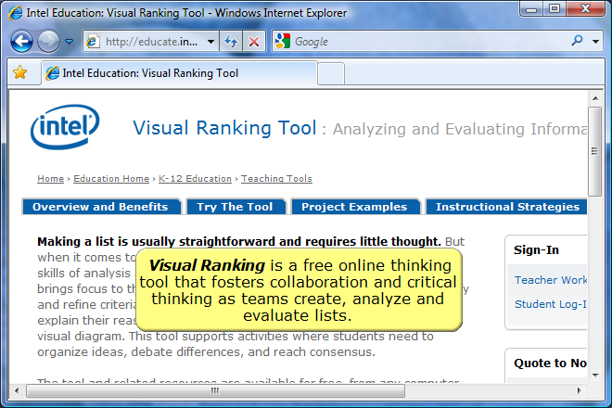
Slide 2
Slide notes:
Text Captions: Visual Ranking is a free online thinking tool that fosters collaboration and critical thinking as teams create, analyze and evaluate lists.

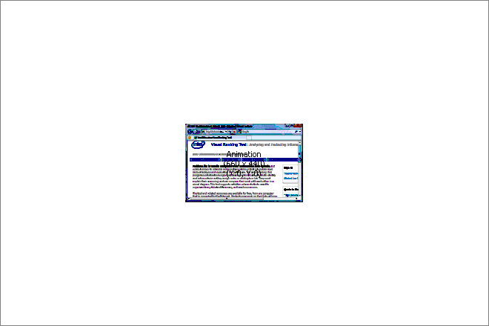
Slide 3
Slide notes:

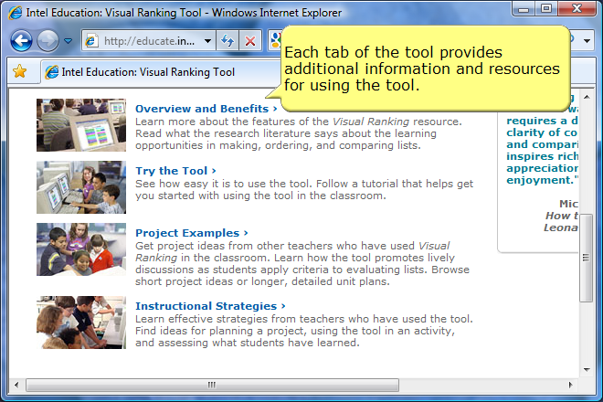
Slide 4
Slide notes:
Text Captions: Each tab of the tool provides additional information and resources for using the tool.


Slide 5
Slide notes:

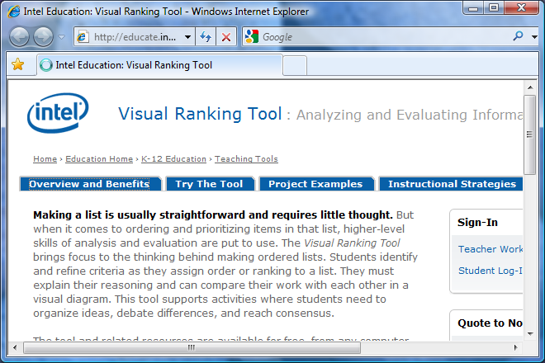
Slide 6
Slide notes:

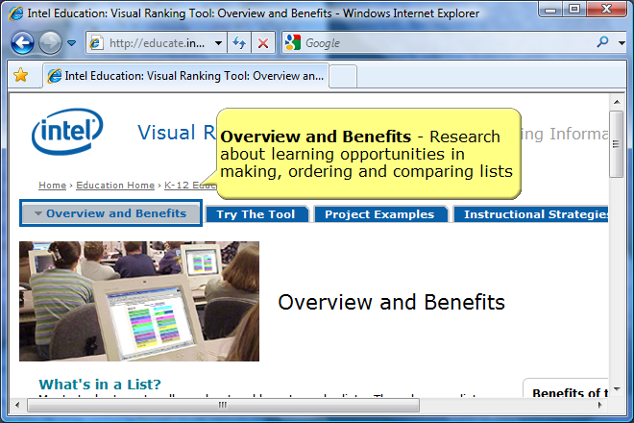
Slide 7
Slide notes:
Text Captions: Overview and Benefits - Research about learning opportunities in making, ordering and comparing lists

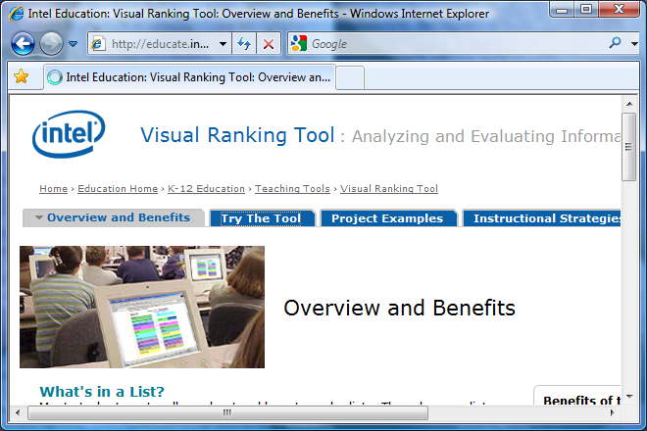
Slide 8
Slide notes:

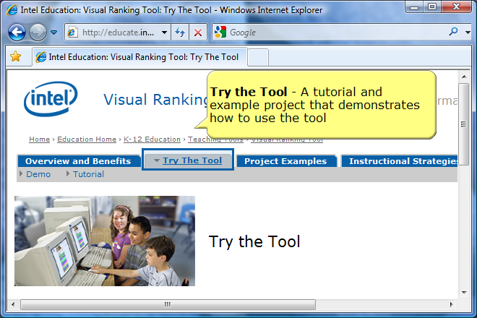
Slide 9
Slide notes:
Text Captions: Try the Tool - A tutorial and example project that demonstrates how to use the tool

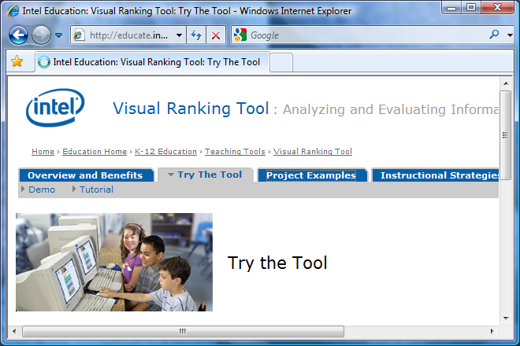
Slide 10
Slide notes:

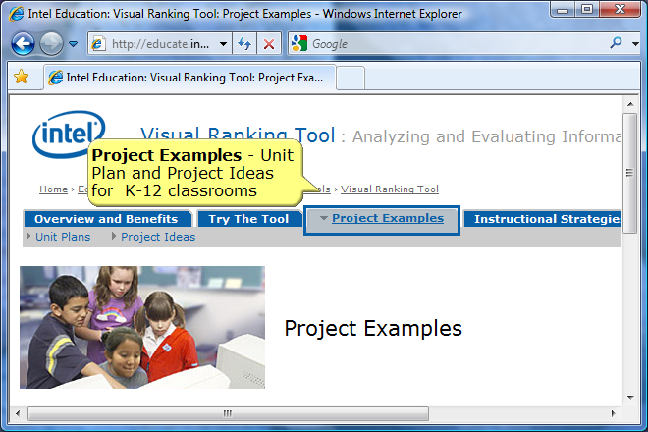
Slide 11
Slide notes:
Text Captions: Project Examples - Unit Plan and Project Ideas for K-12 classrooms

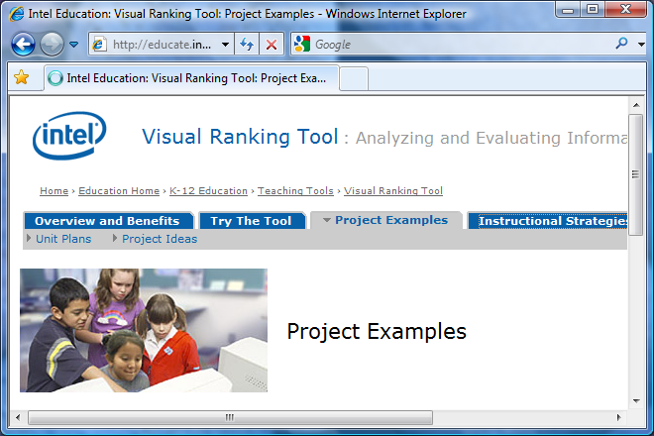
Slide 12
Slide notes:

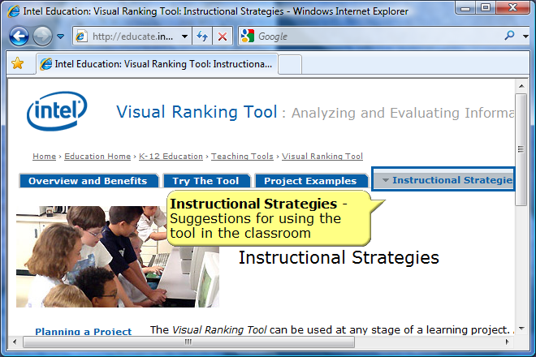
Slide 13
Slide notes:
Text Captions: Instructional Strategies - Suggestions for using the tool in the classroom

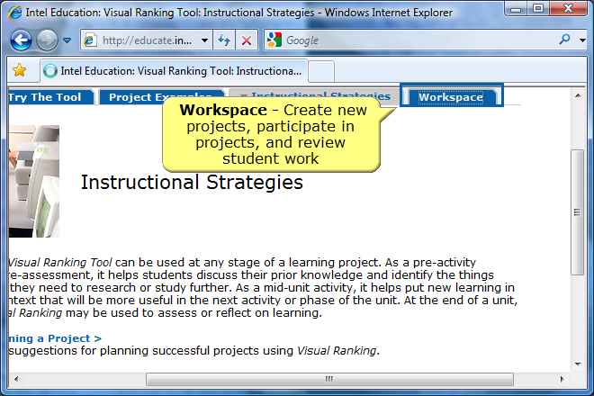
Slide 14
Slide notes:
Text Captions: Workspace - Create new projects, participate in projects, and review student work

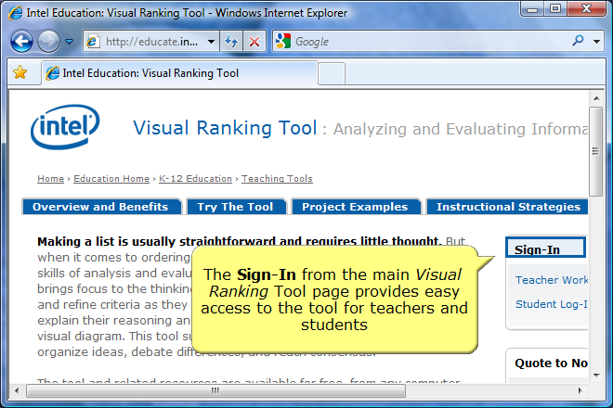
Slide 15
Slide notes:
Text Captions: The Sign-In from the main Visual Ranking Tool page provides easy access to the tool for teachers and students

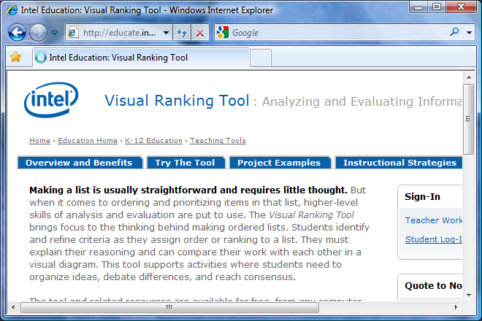
Slide 16
Slide notes:

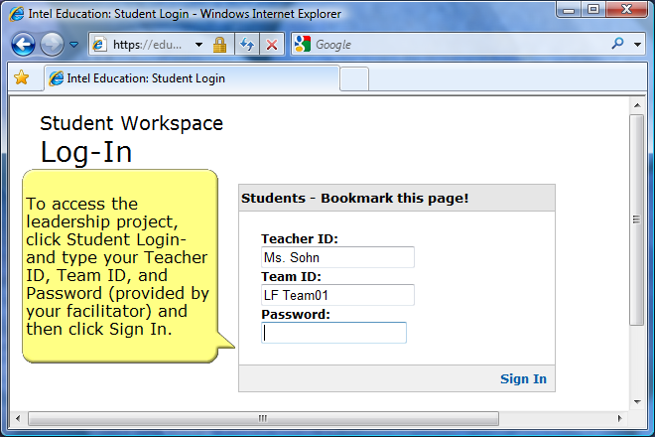
Slide 17
Slide notes:
Text Captions: To access the leadership project, click Student Login- and type your Teacher ID, Team ID, and Password (provided by your facilitator) and then click Sign In.

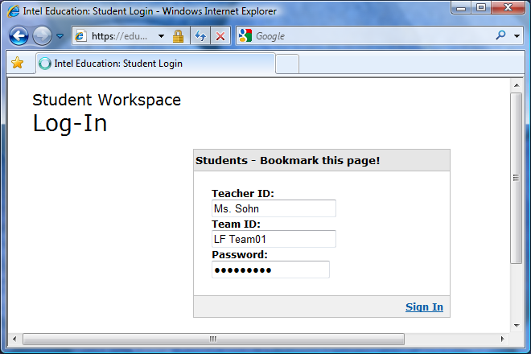
Slide 18
Slide notes:

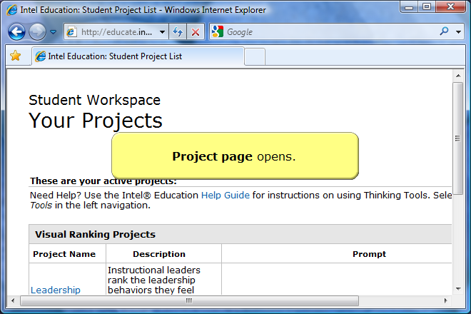
Slide 19
Slide notes:
Text Captions: Project page opens.


Slide 20
Slide notes:

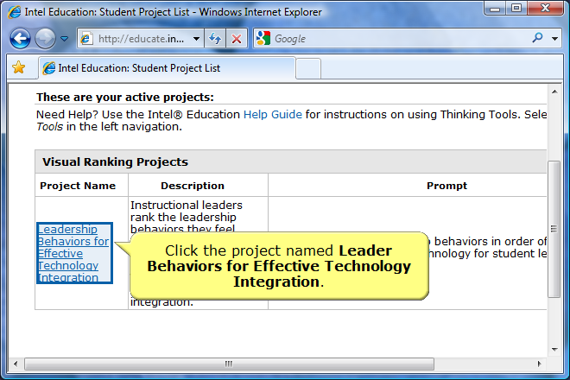
Slide 21
Slide notes:
Text Captions: Click the project named Leader Behaviors for Effective Technology Integration.

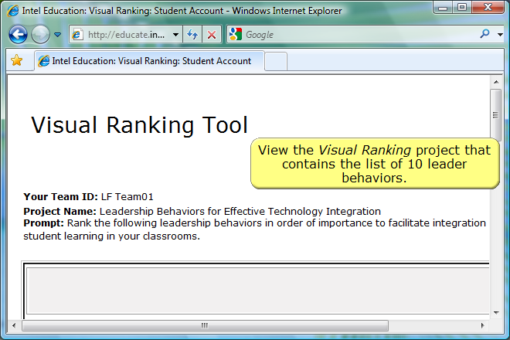
Slide 22
Slide notes:
Text Captions: View the Visual Ranking project that contains the list of 10 leader behaviors.

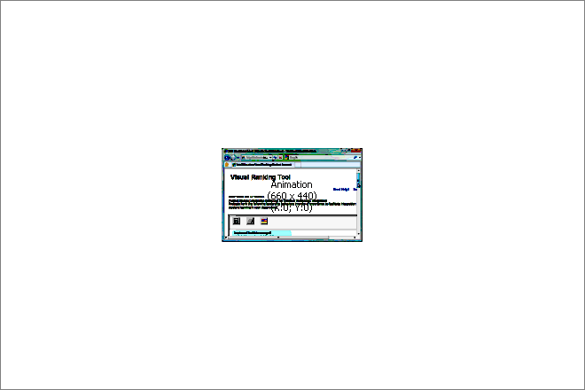
Slide 23
Slide notes:

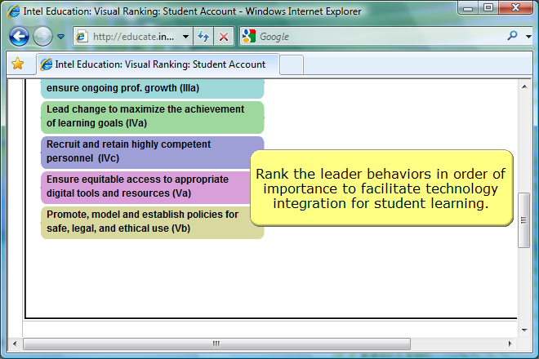
Slide 24
Slide notes:
Text Captions: Rank the leader behaviors in order of importance to facilitate technology integration for student learning.

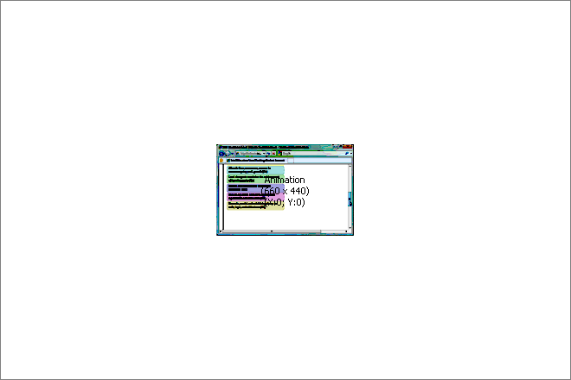
Slide 25
Slide notes:

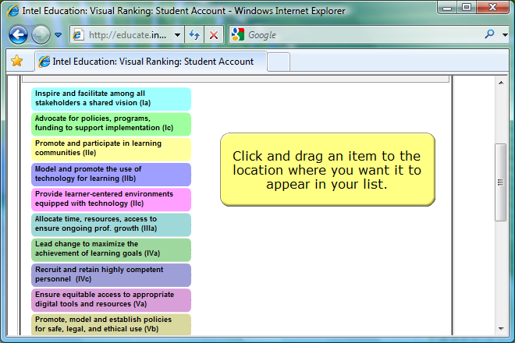
Slide 26
Slide notes:
Text Captions: Click and drag an item to the location where you want it to appear in your list.

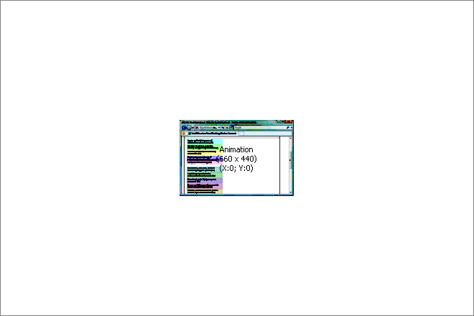
Slide 27
Slide notes:

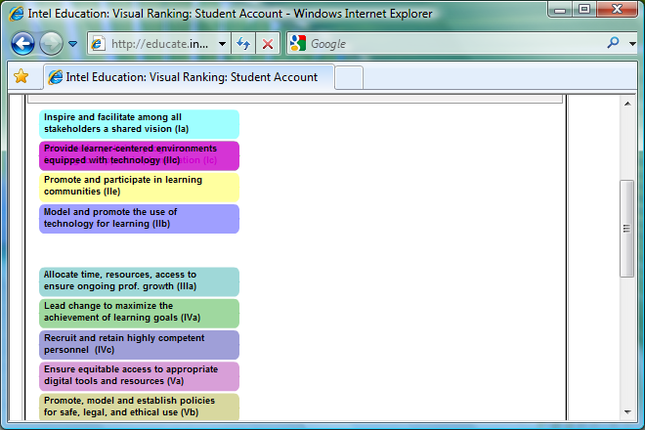
Slide 28
Slide notes:

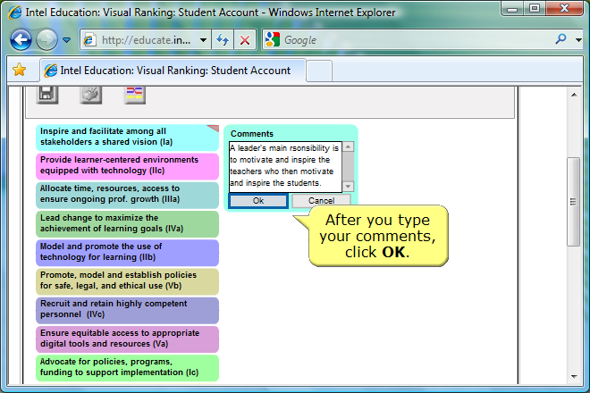
Slide 29
Slide notes:
Text Captions: After you type your comments, click OK.

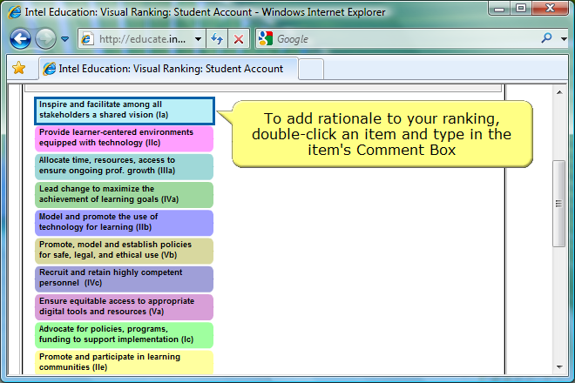
Slide 30
Slide notes:
Text Captions: To add rationale to your ranking, double-click an item and type in the item's Comment Box

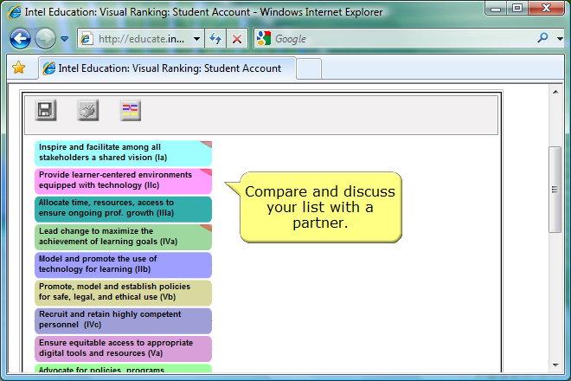
Slide 31
Slide notes:
Text Captions: Compare and discuss your list with a partner.

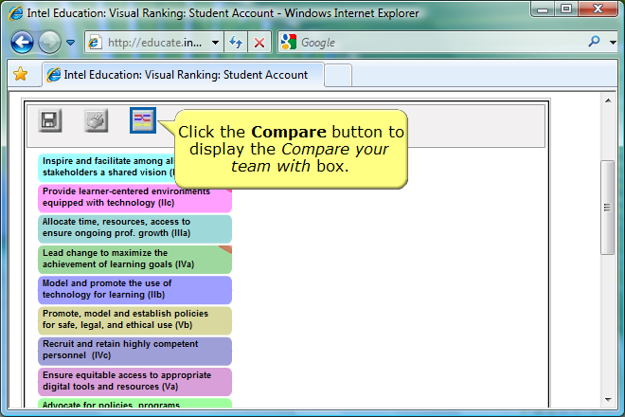
Slide 32
Slide notes:
Text Captions: Click the Compare button to display the Compare your team with box.

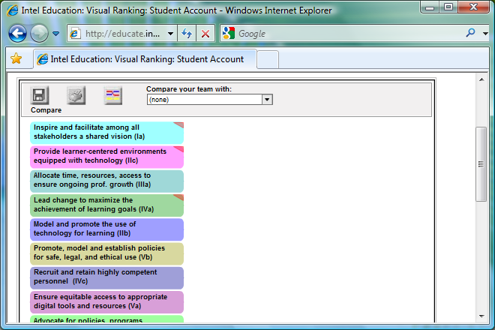
Slide 33
Slide notes:

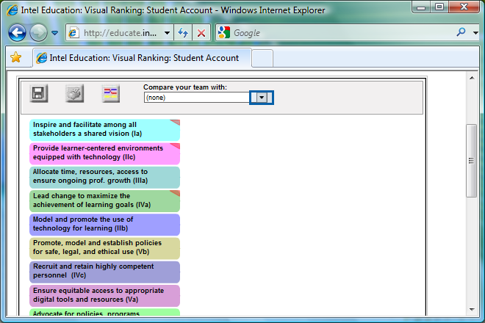
Slide 34
Slide notes:

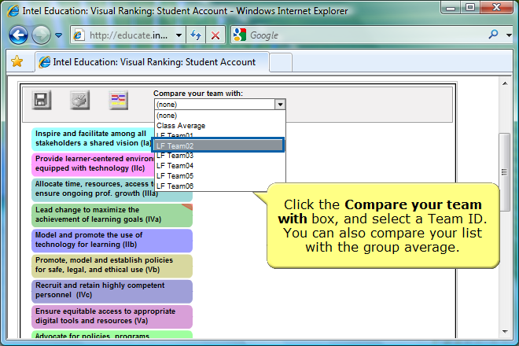
Slide 35
Slide notes:
Text Captions: Click the Compare your team with box, and select a Team ID. You can also compare your list with the group average.

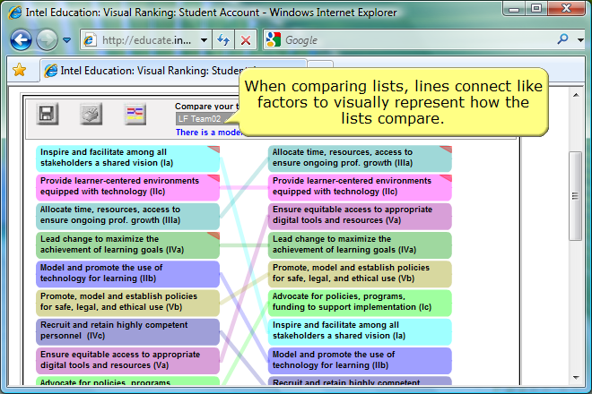
Slide 36
Slide notes:
Text Captions: When comparing lists, lines connect like factors to visually represent how the lists compare.

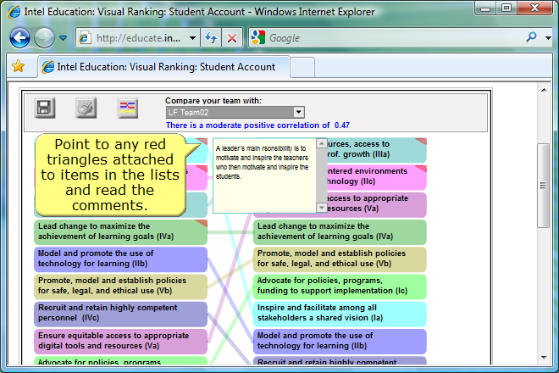
Slide 37
Slide notes:
Text Captions: Point to any red triangles attached to items in the lists and read the comments.

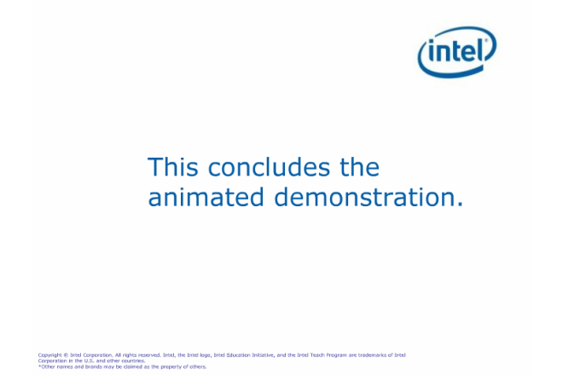
Slide 2
Slide notes:

