Intel STEM Index

Left Column: Please use a secondary navigation module.
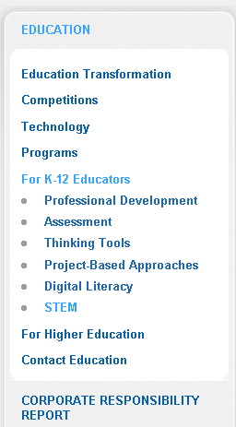

Body – Please use a 1 column Content Module componenet
STEM Unit Plans
Explore technology rich units that use project-based approaches to support the Science, Technology, Engineering, and Math Curriculum. Intel believes that young people are the key to solving global challenges. A solid math and science foundation coupled with skills such as critical thinking, collaboration and problem solving are crucial for their success.
Designing Effective Projects (link to http://educate.intel.com/en/projectdesign/)
Follow a design process for creating successful projects that integrate technology; browse a library of project-based units to adapt for your own use.
Project-Based Math Units (Programming note: each unitplan name is a link to the unitplan and should open in a new window)
Grades K-2
Multimedia Morning Mania: How do we make meaning with symbols? (Grade: K-2)
Seasoning the School Year: How does the world change during the year? (Grade: K-2)
Healthy Eating: Are We What We Eat?: Are we really what we eat? (Grade: K-2)
Meet the Bears: Are we like other animals? (Grade: 2)
My Family: Past, Present, and Future: How will I make a difference? (Grade: 2)

Grades 3-5
Wave of Spring: What changes do you see? (Grade: 3-5)
Fractions Made Visual: Does accuracy really matter that much? (Grade: 3-5)
Food for Thought: How can I stay healthy? (Grade: 5)
Grades 6-8
How Can I Relate to a Million or a Billion?: How can I relate? (Grade: 5-7)
Fair Games: Is life fair? (Grade: 6-8)
Metric Madness: How can math help me understand my world? (Grade: 6-8)
Forensics: How are math and science put to work in the real world? (Grade: 6-8)
Grades 9-12
Play Ball!: How can we use mathematics to help us understand daily life? (Grade: 7-10)
Choreographing Math: How can we communicate through movement? (Grade: 8-10)
Energy Innovations: What is a quality life? (Grade: 9-10)
Track the Trends: Predict the Future?: What does the past tell us about the future? (Grade: 9-12)
What Does This Graph Tell You?: Why is studying change important? (Grade: 9-12)
Pedal Power: How does math help us understand our world? (Grade: 10-12)
Project-Based Science Units
Grades K-2
Seasoning the School Year: How does the world change during the year? (Grade: K-2)
Healthy Eating: Are We What We Eat?: Are we really what we eat? (Grade: K-2)
Pondwater and Pollywogs: Why do people say, “There is no place like home”? (Grade: K-2)
Multimedia Morning Mania: How do we make meaning with symbols? (Grade: K-2)
Meet the Bears: Are we like other animals? (Grade: 2)
Teacher's Pet: Do animals and humans need each other? (Grade: 2-3)
Grades 3-5
African Adventure Safari: What is the price of life? (Grade: 3-5)
Float That Boat!: How can we explain the things that happen around us? (Grade: 3-5)
Go-Go Gadget: Invent a Machine: How can we make life easier? (Grade: 3-5)
Healthy Oceans, Healthy Planet: How are we interconnected? (Grade: 3-5)
The Great Bean Race: Is conquering the impossible possible? (Grade: 3-5)
Wave of Spring: What changes do you see? (Grade: 3-5)
Food for Thought: How can I stay healthy? (Grade: 5)
Grades 6-8
Beat the Heat: What effects do our choices have on the world around us? (Grade: 6-8)
Don't Trash the Earth: Social responsibilities—who decides? (Grade: 6-8)
Forensics: How are math and science put to work in the real world? (Grade: 6-8)
Rock Our Town: What changes do you see? (Grade: 6-8)
Starquest: What can we learn from the night sky? (Grade: 6-8)
The Earth Moves Under My Feet: How does change affect the future? (Grade: 6-8)
Insects: The Good, the Bad and the Ugly: How are things around me helpful or harmful? (Grade 6-8)
What Happened to Robin?: How can I help protect urban wildlife? (Grade: 6-8)
Plugging In to the Sun: What causes scientists to consider new alternatives to solve problems? (Gr. 6-8)
Density: Got Gas?: How is science applied in the real world? (Grade: 6-9)
Grades 9-12
Composting: Why Bother?: How can I contribute to making a better tomorrow? (Grade: 8-10)
Designer Genes: One Size Fits All?: Just because we can, should we? (Grade: 8-10)
Cell-to-Cell: What's the connection? (Grade: 9)
Biomes: Action for a Healthy Planet: What can I do to affect the future? (Grade: 9-10)
Energy Innovations: What is a quality life? (Grade: 9-10)
Lights, Camera, Reaction!: What causes change? (Grade: 9-10)
Using Electricity on the Job: Why care about Earth? (Grade: 9-12)
What Does This Graph Tell You?: Why is studying change important? (Grade: 9-12)
Help Wanted: Physicist!: Just because we can, should we? (Grade: 11-12)
Phabulous Physics: Can all the events around us be anticipated and explained? (Grade: 11-12)
Back to Top
Thinking Tools (link to http://www.intel.com/about/corporateresponsibility/education/k12/tools.htm)
Intel® Education thinking tools are based on research that demonstrates the value of visual representation in constructing and retaining new information. Teachers create online workspaces for students to engage in robust discussions, analyze complex information, pursue investigations, and solve problems.
Visual Ranking Tool: STEM Unit Plans (Programming note: each unitplan name is a link to the unitplan and should open in a new window)
Grow a Business: Why take the risk? (Grade: 3-5)
Playground Design: How can our voice be heard? (Grade: 3-5)
What are the Chances?: What's fair? (Grade: 3-5)
Classify Animals: Does everything have its place? (Grade: 5-8)
River City Water: How do we affect our natural environment? (Grade: 9-12)
Seeing Reason Tool: STEM Unit Plans (Programming note: each unitplan name is a link to the unitplan and should open in a new window)
Getting Along: What pulls us apart and brings us together? (Grade: K-2)
Habitat Conflict: How can we all live together? (Grade: 5-7)
Weather: Why is it important to be prepared? (Grade 6-8)
Ecology Explorers: How can we all get along? (Grade: 6-8)
Bridge the Gap: How can math help me understand my world? (Grade: 6-9)
Why Math?: What processes do you use to make important decisions? (Grade: 9-10)
Communication Tech: Why change the way things are? (Grade 9-12)
Dream Home: How are our lives affected by the choices we make? (Grade 9-12)
Showing Evidence Tool: STEM Unit Plans (Programming note: each unitplan name is a link to the unitplan and should open in a new window)
Oobleck: Does everything have its place? (Grade: 3)
Space: Why do we explore? (Grade: 6-8)
Examining Change: What happens next? (Grade: 6-10)
Genius Unleashed: How do we explain what happens around us? (Grade: 7-12)
What's in Your Genes?: Just because we can should we? (Grade: 9-12)
Mysterious Malady: How do we decide which scientific claims to believe? (Grade: 10-12)
Back to Top
Assessing Projects (link to http://educate.intel.com/en/AssessingProjects/index.htm)
Create assessments of 21st century skills and develop student-centered assessment strategies. Explore the library for exemplary assessments that you can modify for your classroom using the Assessing Projects application.
Explore STEM Assessment Plans (Programming note: each unitplan name is a link to the unitplan and should open in a new window)
Dangerous Animals: How do we know what is real and what is make believe?
Grades K-2, Language Arts, Science, Health
Fraction Quest: Does accuracy really matter that much?
Grades 3-5, Math
Storm Watch: How do people respond to change?
Grades 4-6, Science, Math, Language Arts
Accidental Discoveries: How can we benefit from our accidents?
Grades 6-8, Science

Please include a highlights Module Medium

Use Other STEM Higlights instead of featured stories

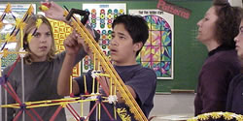
Highlight 1:

It’s a Wild Ride: A STEM Case Study (link to http://educate.intel.com/en/WildRide/)
Image thumbnail from Alison
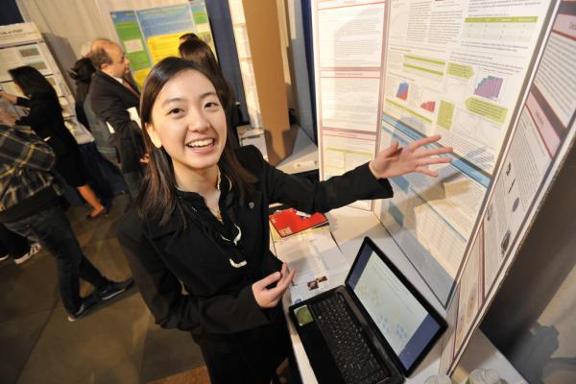
Highlight 2:

Intel ISEF Middle School Science Fair: A Guide for Teachers (link to http://www.intel.com/education/isef/middleschool.htm)
Image thumbnail from Alison


Highlight 3:

Technology Literacy: A comprehensive middle school curriculum (link to http://www.intel.com/education/technologyliteracy/index.htm)
Image thumbnail from Alison

